**TASK 5: Areas between graphs and the *x*-axis**

**In-class Investigation**

**Unit 3**

**Topic 3.2: Integrals**

**Course-related information**

The concepts included in this investigation relate to the following dot points within the WA Mathematics Methods syllabus:

3.2.10 examine the area problem and use sums of the form to estimate the area under the curve

3.2.15 examine the concept of the signed area function

* + 1. calculate the area under a curve

The ability to choose and use appropriate technology to enhance and extend concept development are also incorporated within some of the items.

**Background information**

Students should be given this task before integration skills or concepts have been taught in class, although they will need to be familiar with the idea of anti-differentiation covered as part of the Year 11 Methods course and have covered the differentiation of trigonometric functions.

**Task conditions**

Students will need to have access to a CAS calculator for this in-class investigation task.

# Name:………………………….

# INVESTIGATION 1, 2018: Areas between graphs and the *x*-axis

**In-class Investigation 36 marks**

**Calculator allowed 55 minutes**

**Notes:** Make sure your calculator is in radians

The formula for the area of a trapezium with

parallel sides **a** and **b** and perpendicular height **h** is ***A* = ½(*a + b*)*h***

The aim of this investigation is to look for a method of finding areas between curves and the *x*-axis. For example, what is the area (exactly) shaded in the diagram below, where 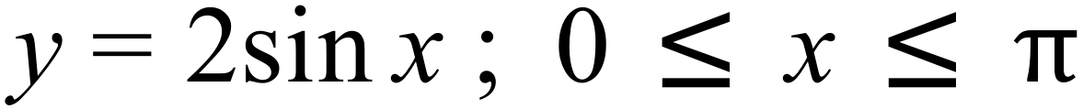.

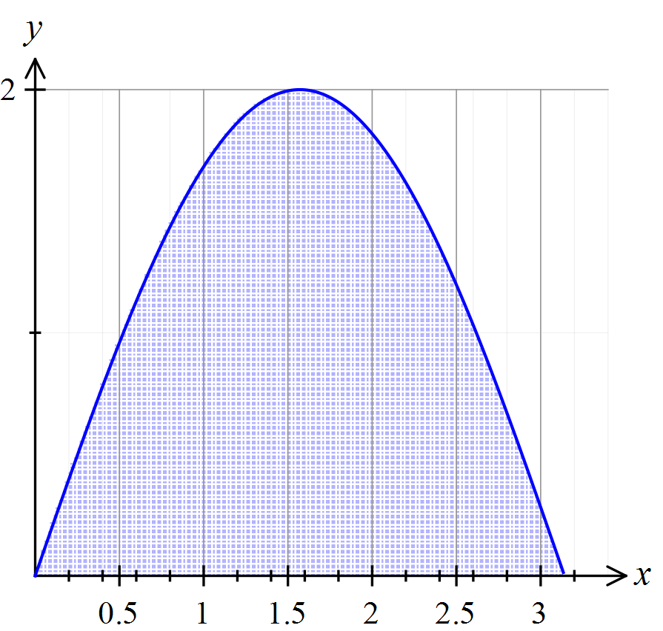

Let us start by doing an easier problem first.

**Question 1 (8 marks)**

Consider the graph of the function  .

Define a function 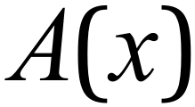 to be the area bounded by the ‘curve’ 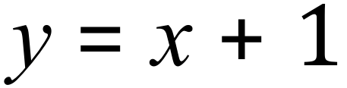and the

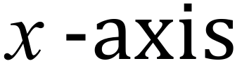 between 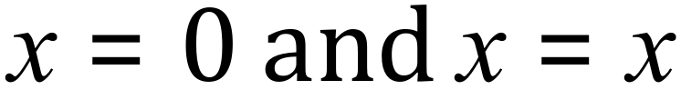 .

|  |  |
| --- | --- |
| For example, the area  = area of a 3 x 1 rectangle plus the area of 3  x 3 right triangle. So, |  |

|  |  |
| --- | --- |
| And, |  |

1. Complete the table below: (3 marks)

|  |  |  |  |  |  |  |  |  |
| --- | --- | --- | --- | --- | --- | --- | --- | --- |
|  | 1 | 2 | 3 | 4 | 5 | 6 | 7 | 8 |
|  | 1.5 | 4 | 7.5 | 12 | 17.5 |  |  |  |

1. State a general rule for  explaining how you arrived at it. (2 marks)

1. Consider the relationship between  and 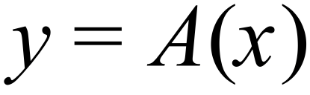

State how  could be derived from  and also how  could be derived from . (3 marks)

**Question 2 (8 marks)**

Now repeat this exercise for the linear function.

1. Draw a sketch of the function on the axes provided. (2 marks)

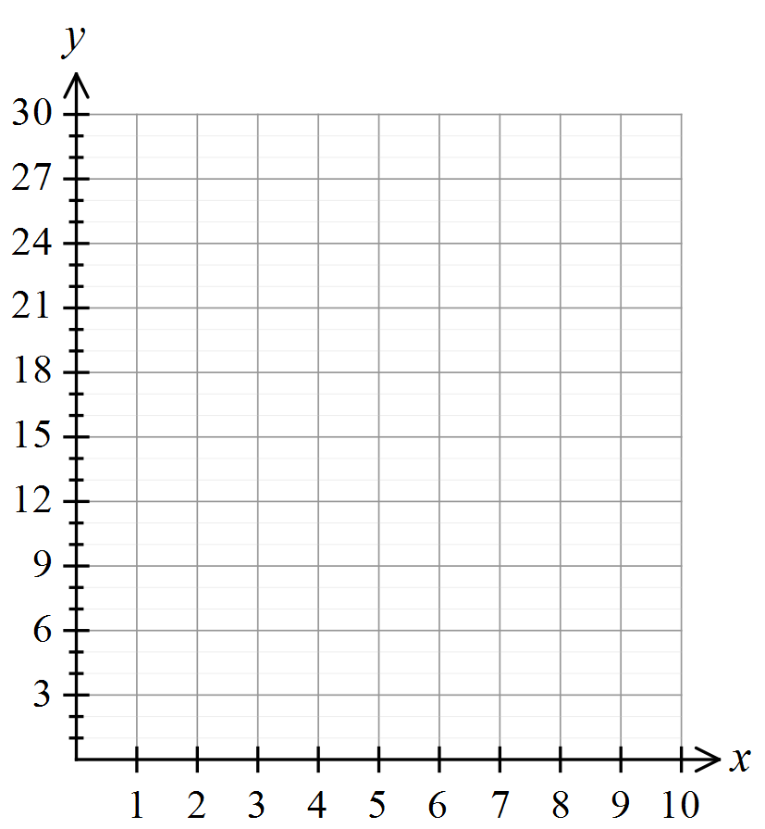

1. Complete the table of values for  at each respective point 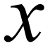, indicating how you calculated at least one of the areas, . (2 marks)

|  |  |  |  |  |  |  |  |  |
| --- | --- | --- | --- | --- | --- | --- | --- | --- |
|  | 1 | 2 | 3 | 4 | 5 | 6 | 7 | 8 |
|  | 3.5 | 10 |  |  | 47.5 | 68 |  | 112 |

1. State a general rule for indicating/explaining how it was arrived at, noting any connection between  and  considering how each could be derived from the other. (4 marks)

Now let us go back to the original example involving 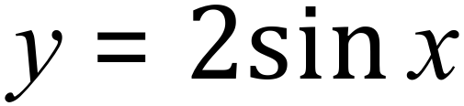 and find an approximation for the area under the curve in this case. If we ‘partition’ (divide or cut up into small parts or pieces) the area in question into a series of ‘trapeziums’, we can add these up to get a rough approximation for the area required. Consider the diagram below.

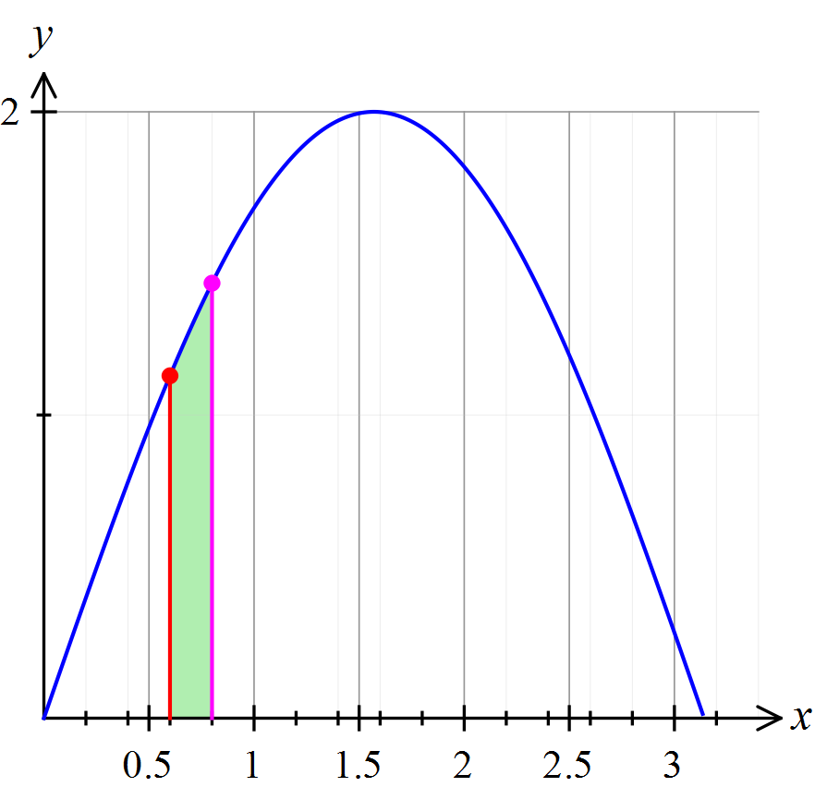

If the partitions are ‘small enough’, we can reasonably assume that the area of the shaded shape will approximately be the same as that of a ‘trapezium’ of width 0.2 and length of parallel sides,respectively. Hence the area of the shaded ‘trapezium’ will be 

Or on a calculator…

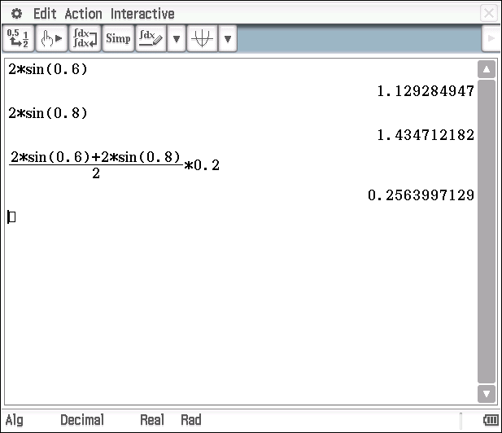

Let us defined  to be the total area bounded by the curve 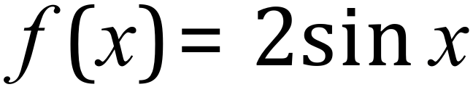 and the 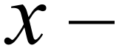 axis on the interval 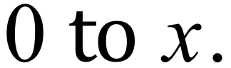

This is illustrated in the diagram below.

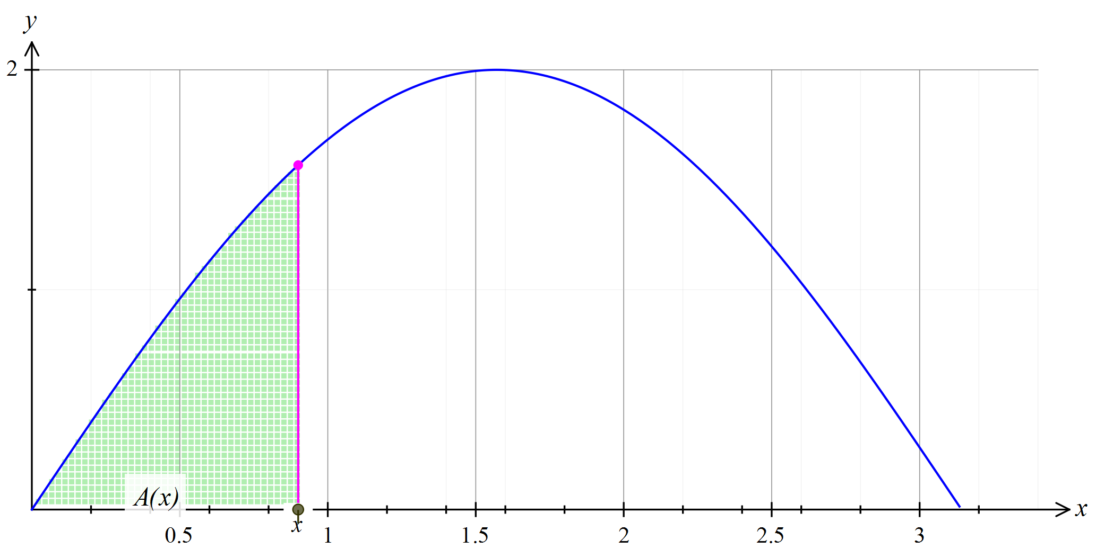

**Question 3 (11 marks)**

1. Use your calculator to complete the following table: (4 marks)

|  |  |  |  |  |  |  |  |  |  |
| --- | --- | --- | --- | --- | --- | --- | --- | --- | --- |
|  | 0 | 0.2 | 0.4 | 0.6 | 0.8 | 1 | 1.2 | 1.4 | 1.6 |
|  |  | 0.040 | 0.118 | 0.191 | 0.256 | 0.312 |  | 0.383 | 0.397 |
|  | 0 | 0.040 | 0.157 | 0.348 | 0.604 | 0.916 |  | 1.655 | 2.052 |

* - represents the area of each partition (or slice)

|  |  |  |  |  |  |  |  |  |
| --- | --- | --- | --- | --- | --- | --- | --- | --- |
|  | 1.8 | 2.0 | 2.2 | 2.4 | 2.6 | 2.8 | 3.0 |  |
|  | 0.394 | 0.377 |  |  | 0.238 | 0.170 | 0.095 | 0.028 |
|  | 2.446 | 2.823 |  |  | 3.701 | 3.871 | 3.967 | 3.995 |

1. Use your calculations, to state an approximate value for the area underneath

. (2 marks)

An interesting challenge is to try to find an algebraic expression for  within the given domain, 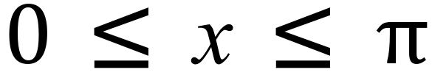.

1. Make a generalisation about how  may be related to. You may wish to refer back to your results from questions 1 and 2, to help you with this.

(2 marks)

1. Test your generalisation for  in part (c) above, by comparing corresponding values from part (b) and explaining any variations or by refining your generalisation. The table below may help. (3 marks)

|  |  |  |  |  |  |  |  |  |  |
| --- | --- | --- | --- | --- | --- | --- | --- | --- | --- |
|  | 0 | 0.2 | 0.4 | 0.6 | 0.8 | 1 | 1.2 | 1.4 | 1.6 |
|  | 0 | 0.040 | 0.157 | 0.348 | 0.604 | 0.916 |  | 1.655 | 2.052 |
|  |  |  |  |  |  |  |  |  |  |

**Question 4 (9 marks)**

1. Predict the area under the curve 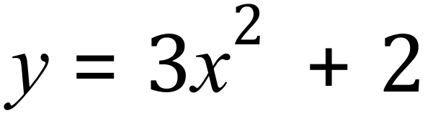 for 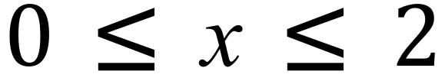 . (3 marks)
2. By completing the table below, determine the area under over the domain  using the partition method. You may find it helpful to use a calculator routine (as indicated below) to complete the table of values required. (4 marks)

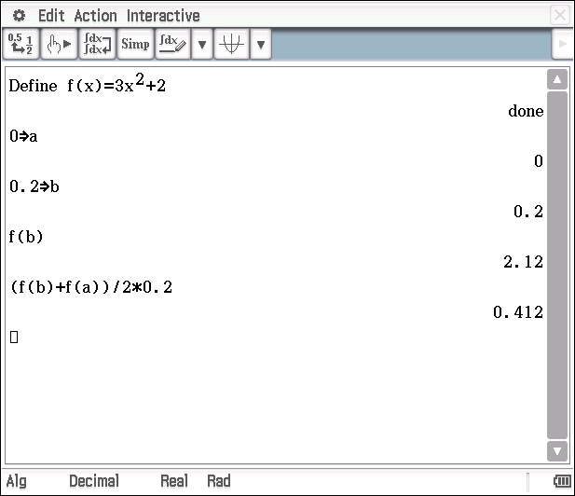 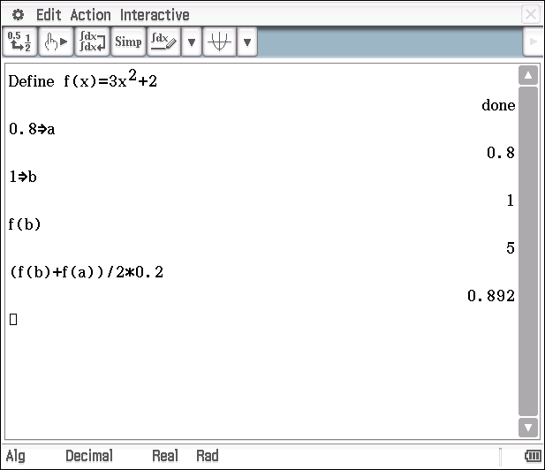

|  |  |  |  |  |  |  |  |  |  |  |  |
| --- | --- | --- | --- | --- | --- | --- | --- | --- | --- | --- | --- |
|  | 0 | 0.2 | 0.4 | 0.6 | 0.8 | 1 | 1.2 | 1.4 | 1.6 | 1.8 | 2 |
|  | 0 | 2.12 | 2.48 | 3.08 | 3.92 | 5 |  | 7.88 |  |  | 14 |
|  |  | 0.412 | 0.46 | 0.556 | 0.70 | 0.892 |  | 1.42 |  |  | 2.572 |
|  | 0 | 0.412 | 0.872 | 1.428 |  |  |  |  |  |  |  |



(working out space if required)

1. Make a statement about how the area found in part 4(b) compares with the area you predicted in 4(a). (2 marks)

**Areas between graphs and the *x*-axis**

**Solutions and marking key In-class investigation**

**Question 1 (a)**

|  |  |
| --- | --- |
| Solution | |
| |  |  |  |  |  |  |  |  |  | | --- | --- | --- | --- | --- | --- | --- | --- | --- | |  | 1 | 2 | 3 | 4 | 5 | 6 | 7 | 8 | |  | 1.5 | 4 | 7.5 | 12 | 17.5 | **24** | **31.5** | **40** | | |
| Mathematical behaviours | Marks |
| * indicates understanding of how to calculate the respective areas (either on diagram/graph or numerically) * correctly calculates one value of * Calculates all values of correctly | 1  1  1 |

**Question 1 (b)**

|  |  |
| --- | --- |
| Solution | |
| , this can be arrived at by noting that the second difference of the sequence in the table is constant (=1) and hence testing for a quadratic expression.  Alternatively, noting that the area of triangle (up to ) =  and the area of the rectangle (up to ) =. Summing the two gives the required expression. | |
| Mathematical behaviours | Marks |
| * Determines a correct expression for * Indicates a reasonable method of arriving at | 1  1 |

**Question 1 (c)**

|  |  |
| --- | --- |
| Solution | |
| Notes that . Hence the anti-derivative of  is which is . Thus  is the anti-derivative of with the constant of integration equaling 0. | |
| Mathematical behaviours | Marks |
| * indicates that the derivative of  is * indicates that the anti-derivative of  is * indicates that the constant of integration is 0 (in this case) | 1  1  1 |

**Question 2 (a)**

|  |  |
| --- | --- |
| Solution | |
|  | |
| Mathematical behaviours | Marks |
| Draws a line with the correct    * gradient | 1  1 |

**Question 2 (b)**

|  |  |
| --- | --- |
| Solution | |
| The area  = area of a 3 x 2  Rectangle plus the area of a 3 x 9  right triangle. So,         |  |  |  |  |  |  |  |  |  | | --- | --- | --- | --- | --- | --- | --- | --- | --- | |  | 1 | 2 | 3 | 4 | 5 | 6 | 7 | 8 | |  | 3.5 | 10 | **19.5** | **32** | 47.5 | 68 | **87.5** | 112 | | |
| Mathematical behaviours | Marks |
| * indicates method of calculation for * calculates all values of correctly | 1  1 |

**Question 2 (c)**

|  |  |
| --- | --- |
| Solution | |
| this can be arrived at by noting that the second difference of the sequence in the table is constant (=3) and hence testing for a quadratic expression.  Alternatively, noting that the area of triangle (up to ) =  and the area of the rectangle (up to ) =2. Summing the two gives the required expression.  Also, notes that  which is the original function under which the area is being calculated. Hence = where the constant of integration is equal to zero. | |
| Mathematical behaviours | Marks |
| * Determines a correct expression for * Provides appropriate working or explanation of how  was determined * Indicates that  is an anti-derivative of * Make appropriate mention of the constant of integration | 1  1  1  1 |

**Question 3 (a)**

|  |  |
| --- | --- |
| Solution | |
| |  |  |  |  |  |  |  |  |  |  | | --- | --- | --- | --- | --- | --- | --- | --- | --- | --- | |  | 0 | 0.2 | 0.4 | 0.6 | 0.8 | 1 | 1.2 | 1.4 | 1.6 | |  |  | 0.040 | 0.118 | 0.191 | 0.256 | 0.312 | 0.355 | 0.383 | 0.397 | |  | 0 | 0.040 | 0.157 | 0.348 | 0.604 | 0.916 | 1.271 | 1.655 | 2.052 |   * - represents the area of each partition (or slice)   |  |  |  |  |  |  |  |  |  | | --- | --- | --- | --- | --- | --- | --- | --- | --- | |  | 1.8 | 2.0 | 2.2 | 2.4 | 2.6 | 2.8 | 3.0 |  | |  | 0.394 | 0.377 | 0.343 | 0.297 | 0.238 | 0.170 | 0.095 | 0.028 | |  | 2.446 | 2.823 | 3.166 | 3.463 | 3.701 | 3.871 | 3.967 | 3.995 | | |
| Mathematical behaviours | Marks |
| * determines one value of  correctly * determines all values of  correctly * determines one value of correctly * determines all values of  correctly | 1  1  1  1 |

**Question 3 (b)**

|  |  |
| --- | --- |
| Solution | |
|  | |
| Mathematical behaviours | Marks |
| * indicates the need to subtract * calculates the required area correctly | 1  1 |

**Question 3 (c)**

|  |  |
| --- | --- |
| Solution | |
| Based on questions 1 and 2, it would seem that could be the anti-derivative of . The anti-derivative of is . | |
| Mathematical behaviours | Marks |
| * indicates a link between the area under the curve and the anti-derivative of the function * Suggests or +c or +2 | 1  1 |

**Question 3 (d)**

|  |  |
| --- | --- |
| Solution | |
| Testing prediction for various values of   |  |  |  |  |  |  |  |  |  |  | | --- | --- | --- | --- | --- | --- | --- | --- | --- | --- | |  | 0 | 0.2 | 0.4 | 0.6 | 0.8 | 1 | 1.2 | 1.4 | 1.6 | |  | 0 | 0.04 | 0.157 | 0.348 | 0.604 | 0.916 | 1.271 | 1.655 | 2.052 | |  | -2 | -1.96 | -1.84 | -1.65 | -1.39 | -1.08 | -0.72 | -0.34 | -0.06 |   Note that the difference between  and is 2 (allowing for rounding)  Thus the area under the curve of is the anti-derivative of where the constant of integration is 2. | |
| Mathematical behaviours | Marks |
| * infers that a constant of integration other than 0 is required for the connection between the area and the anti-derivative to apply * completes the table with enough points (correctly) to be able to infer a constant of integration * determines that the constant of integration needs to be 2 | 1  1  1 |

**Question 4 (a)**

|  |  |
| --- | --- |
| Solution | |
| = anti-derivative of      So would predict the area to 12 square units – based on results of questions 1 and 2 and the fact that the function here is similar (increasing and positive within the domain) | |
| Mathematical behaviours | Marks |
| * uses the idea of the area being the anti-derivative * evaluates the anti-derivative at 2 as 12 * acknowledges the possibility of a variation due to the constant of integration | 1  1  1 |

**Question 4 (b)**

|  |  |
| --- | --- |
| Solution | |
| |  |  |  |  |  |  |  |  |  |  |  |  | | --- | --- | --- | --- | --- | --- | --- | --- | --- | --- | --- | --- | |  | 0 | 0.2 | 0.4 | 0.6 | 0.8 | 1 | 1.2 | 1.4 | 1.6 | 1.8 | 2 | |  | 0 | 2.12 | 2.48 | 3.08 | 3.92 | 5 | 6.32 | 7.88 | 9.68 | 11.72 | 14 | |  |  | 0.412 | 0.46 | 0.556 | 0.70 | 0.892 | 1.132 | 1.42 | 1.756 | 2.14 | 2.572 | |  | 0 | 0.412 | 0.872 | 1.428 | 2.128 | 3.020 | 4.152 | 5.572 | 7.328 | 9.468 | 12.04 | | |
| Mathematical behaviours | Marks |
| * determines the correct value of * determines the correct value of * correctly determines more than half of the remaining values * correctly determines all values | 1  1  1  1 |

**Question 4 (c)**

|  |  |
| --- | --- |
| Solution | |
| The predicated area of 12 compares favourably with 12.04 found in part (b).  Would expect the answer in part (b) to be slightly higher due to the use of the sum of  ‘trapeziums’ to determine the area. Each partition is slightly larger than the actual area under the curve | |
| Mathematical behaviours | Marks |
| * any sensible statement of comparison * an explanatory statement such as why the sum of the partitions is larger than the actual area | 1  1 |